MENU:

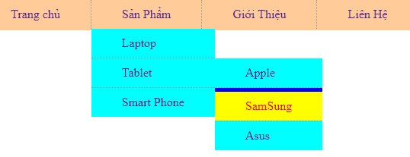

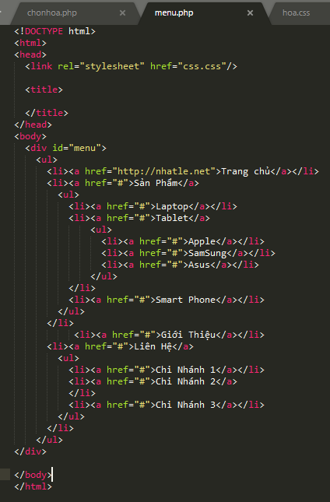

CSS

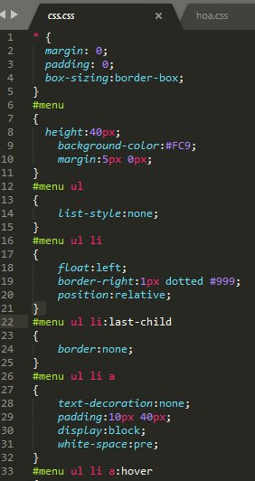 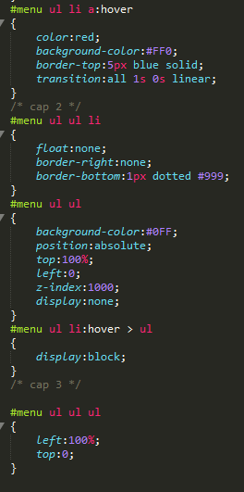

MENU DỌC

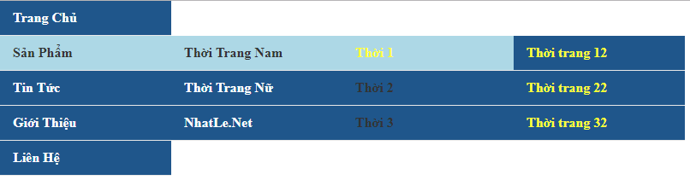

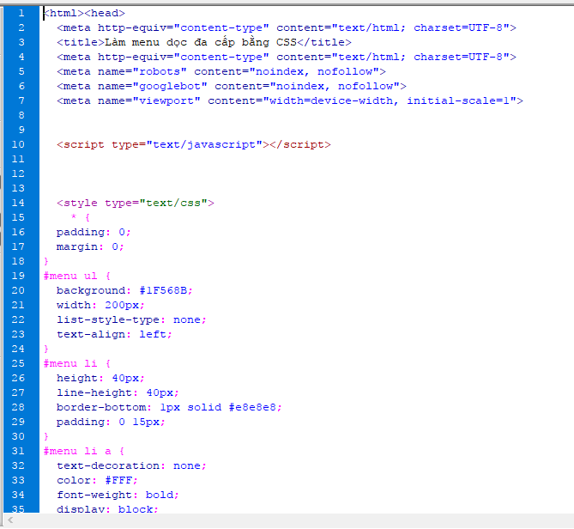

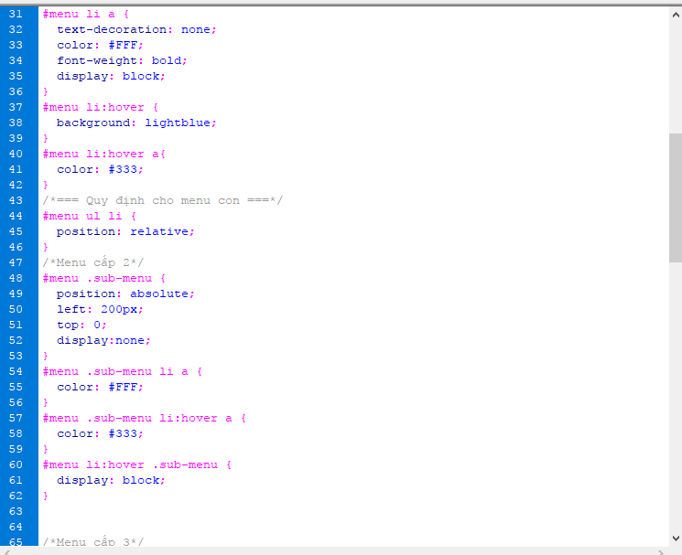

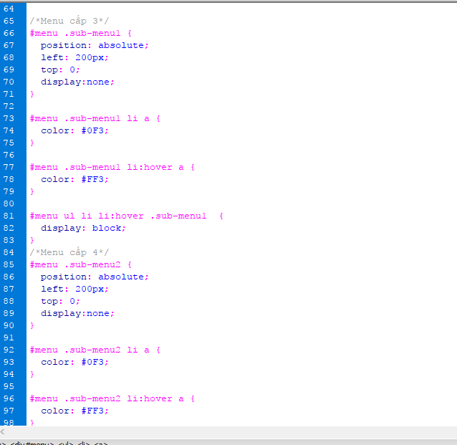

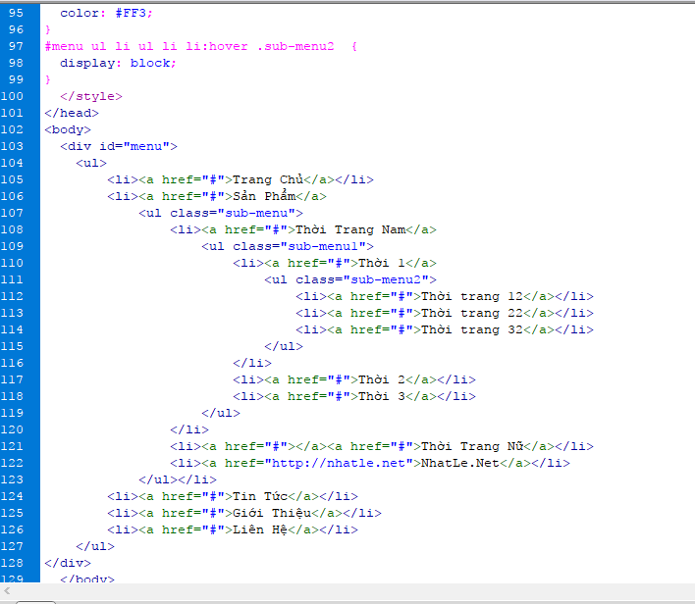

SỰ KIỆN HÌNH ÃNH RÊ CHUỘT

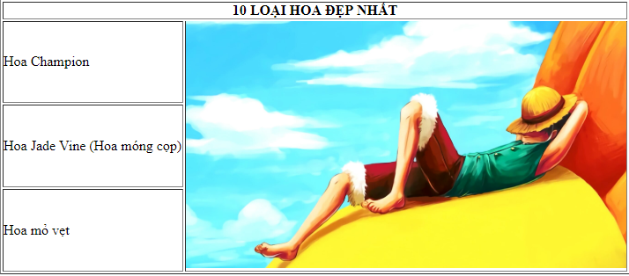

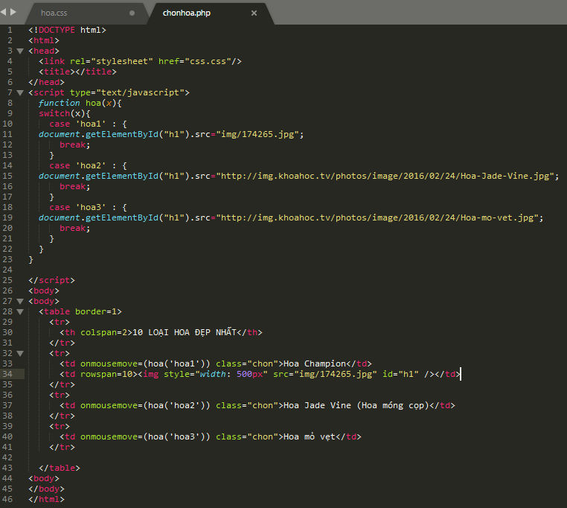

Css

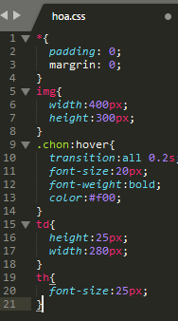 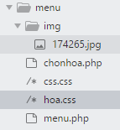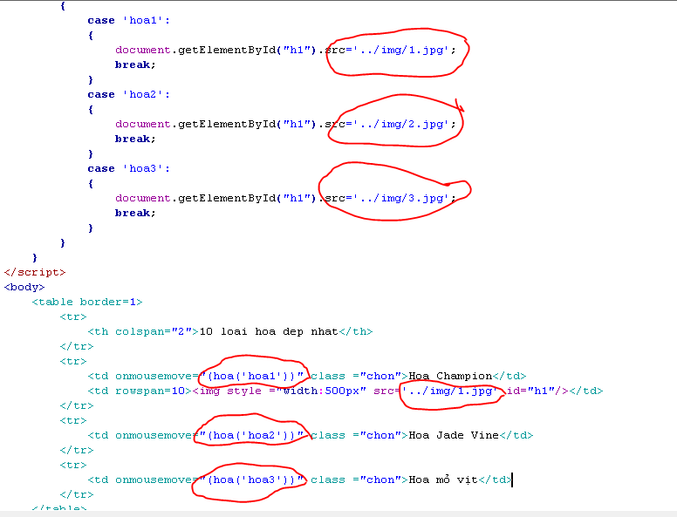

KIỂM TRA SĐT EMAIL

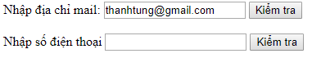

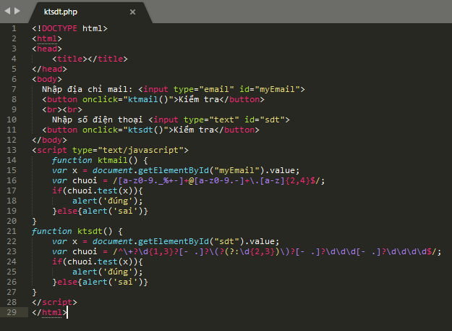

THÊM KHÁCH HÀNG

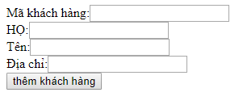

KẾT NỐI

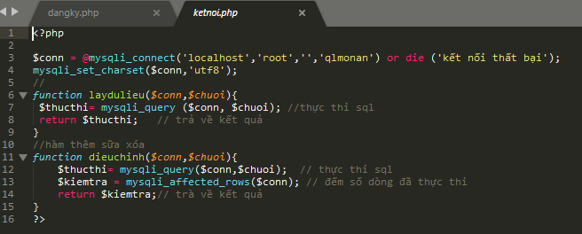

TRANG GIAO DIỆN khách hàng

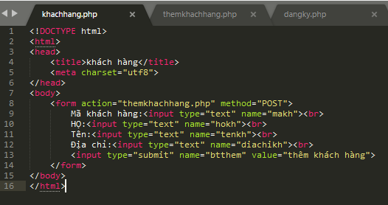

TRANG SỬ LÝ khách hàng

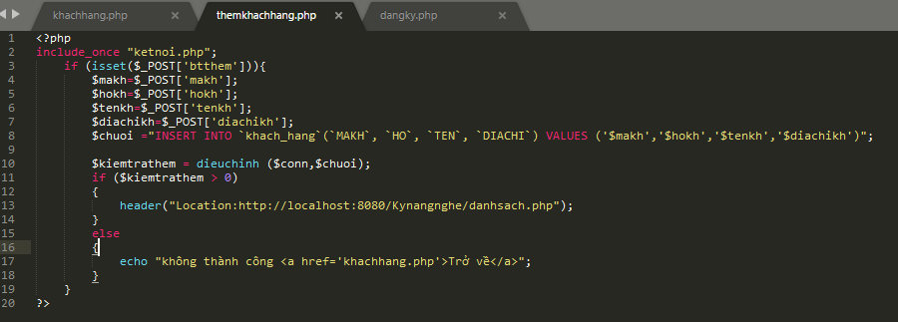

Giao diện trang danh sách

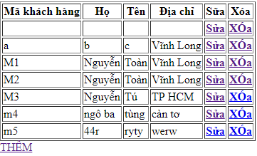

TRANG DANH SÁCH DÙNG ĐỂ HIỂN THỊ DỮ LIỆU TỪ CSDL

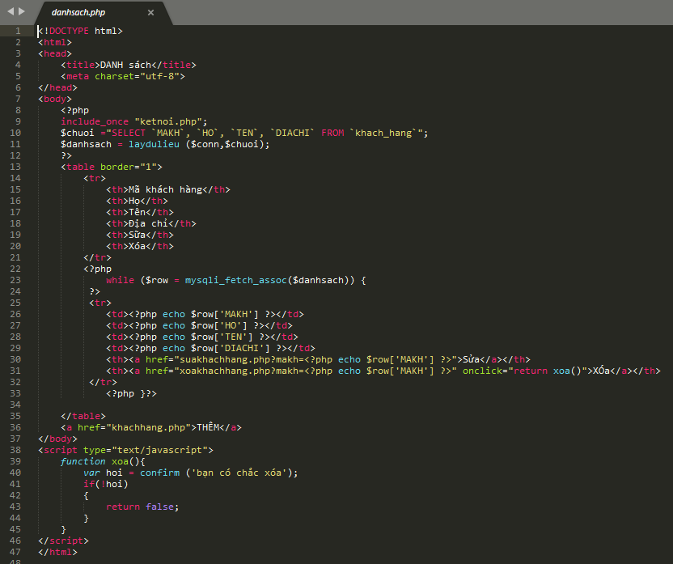

TRANG XÓA

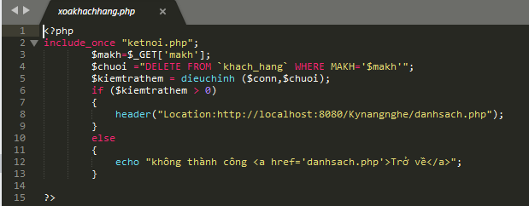

TRANG SỬA

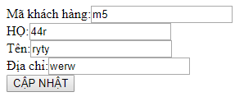

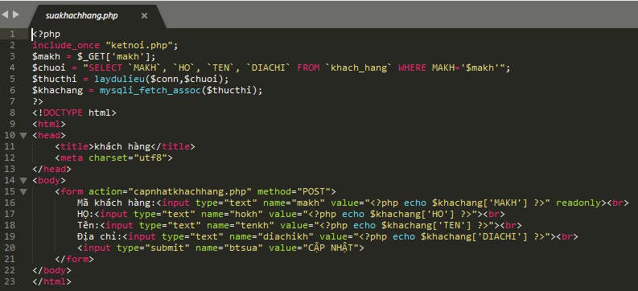

TRANG XỬ LÝ SỬA

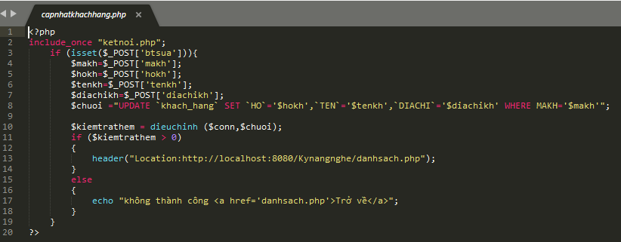

KIỂM TRA ĐĂNG KÝ JAVA SCRIP

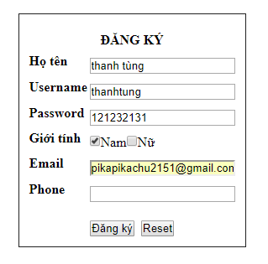

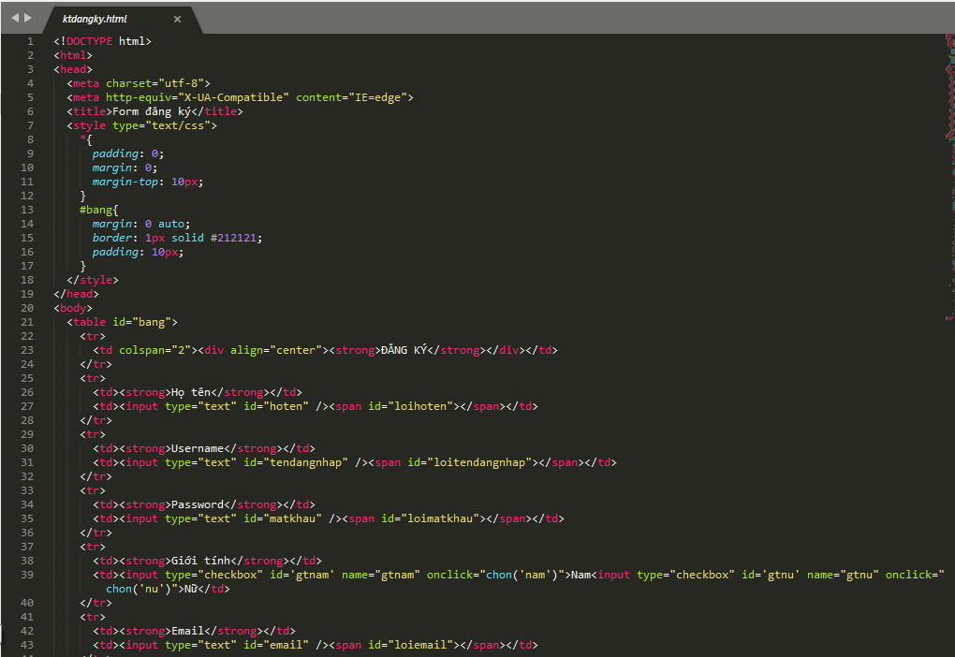

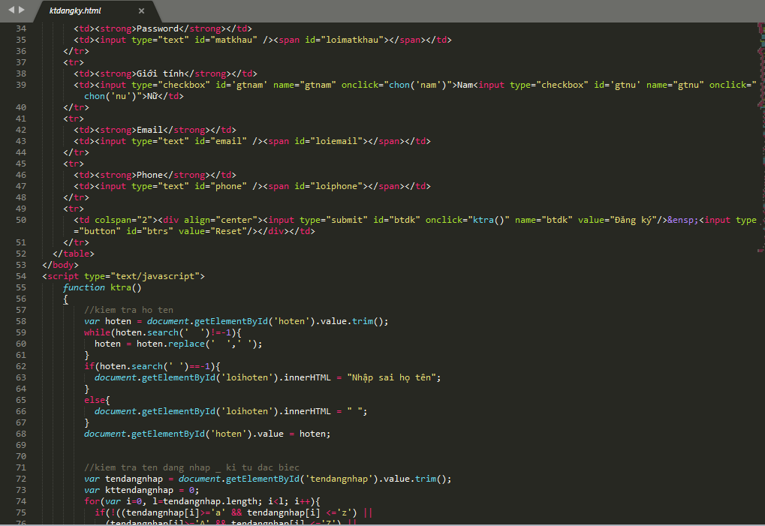

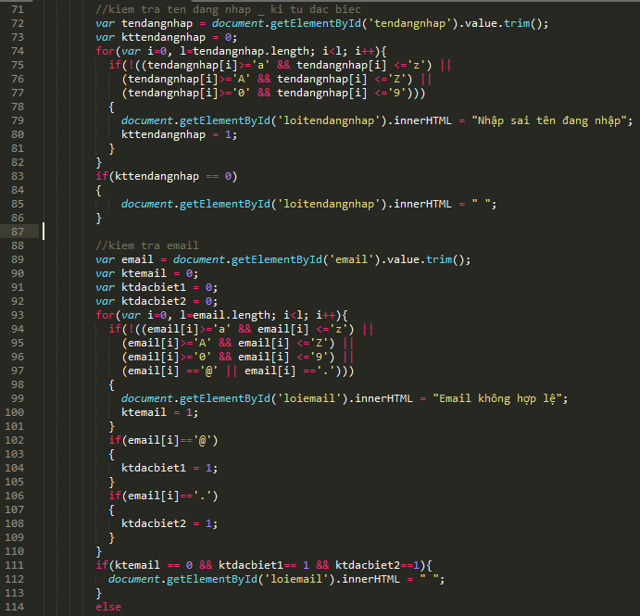

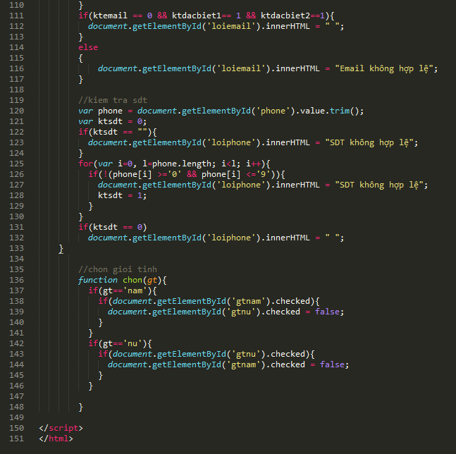

Đăng nhập đăng ký + mysql

Bảng nguoidung

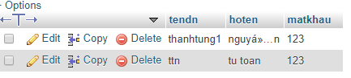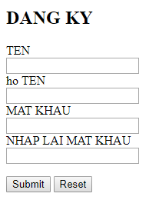

Trang đăng ký

Trang kết nối

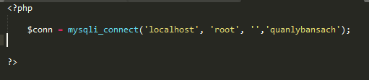

Trang đăng ký HTML

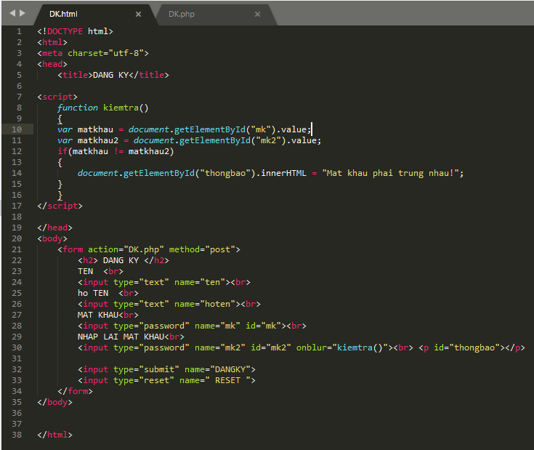

Trang php

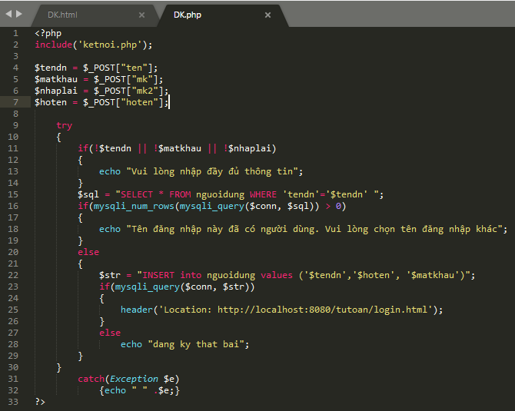

Login

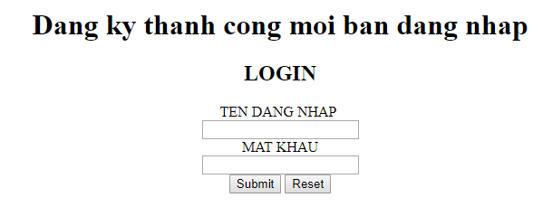

Trang html login

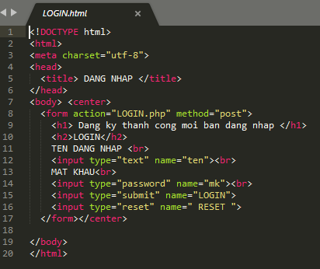

Trang php

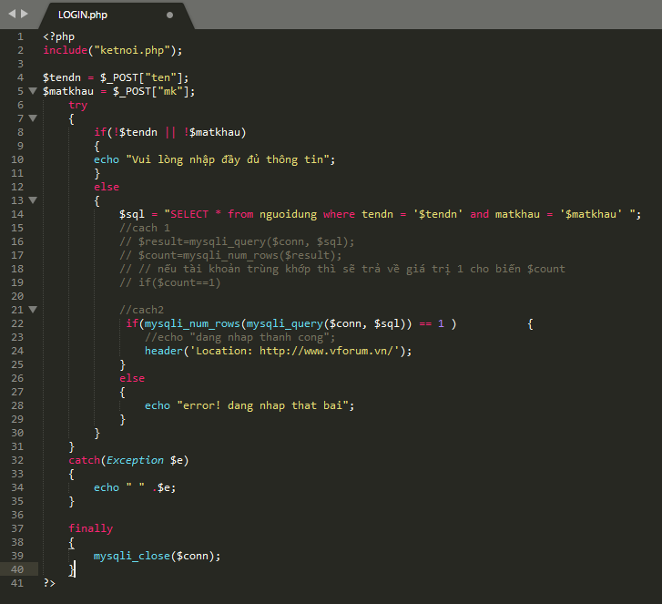

C#



Thuộc tín ẫn text box k cho nhập

* Tạo cell lick nhấn vào datarissviu , vào sấm sét chọn cellclick nhấp đúp.





Ketnoi.cs

using System;

using System.Collections.Generic;

using System.Linq;

using System.Text;

using System.Threading.Tasks;

using System.Data.SqlClient;

using System.Data;

namespace FormDangNhap

{

public static class ketnoi

{

public static string chuoiketnoi = @"Data Source=THANHTUNG;Initial Catalog=Sign;Integrated Security=True";

public static SqlConnection con;

public static SqlCommand cmd;

public static SqlDataAdapter da;

public static void openketnoi()

{

con = new SqlConnection(chuoiketnoi);

con.Open();

}

public static void dongketnoi()

{

con.Close();

}

// phuong thuc get

public static DataTable gettable(string sql)

{

cmd = new SqlCommand(sql, con);

da = new SqlDataAdapter(cmd);

DataTable db = new DataTable();

da.Fill(db);

return db;

}

public static void executeQuery(string sql)

{

cmd = new SqlCommand(sql, con);

cmd.ExecuteNonQuery();

}

}

}

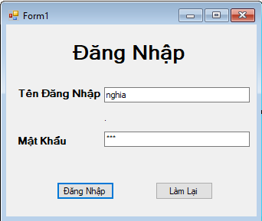

Frmdangnhap.cs

using System;

using System.Collections.Generic;

using System.ComponentModel;

using System.Data;

using System.Data.SqlClient;

using System.Drawing;

using System.Linq;

using System.Text;

using System.Threading.Tasks;

using System.Windows.Forms;

namespace FormDangNhap

{

public partial class frmDangNhap : Form

{

public frmDangNhap()

{

InitializeComponent();

btnlamlai.Visible = false;

}

private void btndangnhap_Click(object sender, EventArgs e)

{

SqlConnection conn = new SqlConnection(@"Data Source=THANHTUNG;Initial Catalog=Sign;Integrated Security=True");

string sqlSelect = "select * from tblTaiKhoan where TaiKhoan = '" + txttendangnhap.Text + "' and MatKhau = '" + txtmatkhau.Text + "'";

conn.Open();

SqlCommand cmd = new SqlCommand(sqlSelect, conn); // câu lệnh kết nối

SqlDataReader reader = cmd.ExecuteReader(); // đăng nhập thành công

btnlamlai.Visible = true;

if(reader.Read() == true)

{

MessageBox.Show("Đăng nhập thành công!");

this.Hide();

Form main = new frmQuanLyGiaoVien();

main.Show();

}

else if( txttendangnhap.Text == "" || txtmatkhau.Text == "")

{

MessageBox.Show("tên đăng nhập hoặc mật khẩu không được để trống!");

}

else if(reader.Read() == false)

{

MessageBox.Show("tên tài khoản và mật khẩu không đúng");

}

}

private void btnlamlai_Click(object sender, EventArgs e)

{

txttendangnhap.Text = "";

txtmatkhau.Text = "";

txttendangnhap.Focus(); // Cho con trỏ luôn ở text đăng nhập

}

private void _formclosing(object sender, FormClosingEventArgs e)

{

DialogResult dr;

dr = MessageBox.Show("Bạn có muốn thoát khỏi chương trình không ?", "Xác nhận", MessageBoxButtons.YesNo, MessageBoxIcon.Question);

if (dr == DialogResult.Yes)

{

//Application.Exit();

}

else

{

e.Cancel = true;

}

}

}

}

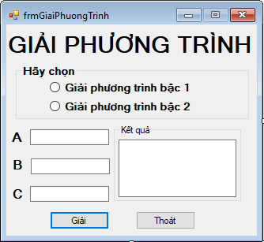

Frmgiaiphuongtrinh.cs

using System;

using System.Collections.Generic;

using System.ComponentModel;

using System.Data;

using System.Drawing;

using System.Linq;

using System.Text;

using System.Threading.Tasks;

using System.Windows.Forms;

namespace FormDangNhap

{

public partial class frmGiaiPhuongTrinh : Form

{

public frmGiaiPhuongTrinh()

{

InitializeComponent();

}

private void button2_Click(object sender, EventArgs e)

{

this.Close();

}

private void frmGiaiPhuongTrinh_Load(object sender, EventArgs e)

{

txtA.Visible = false;

txtB.Visible = false;

txtC.Visible = false;

//rbtnGiaiptbac1.Checked = false;

//rbtnGiaiptbac2.Checked = false;

}

private void btnGiai_Click(object sender, EventArgs e)

{

float a = float.Parse(txtA.Text);

float b = float.Parse(txtB.Text);

double delta, x, x1, x2;

if (rbtnGiaiptbac1.Checked == true)

{

if (a == 0)

{

if (b == 0)

txtKetqua.Text = "phuong trinh vô số nghiem";

else

txtKetqua.Text = "phuong trinh vô nghiệm";

}

else

{

x = (-b / a);

txtKetqua.Text = "x = " + x.ToString();

}

}

else if (rbtnGiaiptbac2.Checked == true)

{

float c = float.Parse(txtC.Text);

if (a == 0)

{

if (b == 0)

{

if (c == 0)

txtKetqua.Text = "Phương Trình Có Vô Số Nghiệm";

else

txtKetqua.Text = "Phương Trình Vô Nghiệm";

}

else

{

x1 = (-c) / b;

txtKetqua.Text = "Phương Trình Có 1 Nghiệm : " + "x1 = " + x1.ToString();

}

}

else

{

delta = b * b - 4 * a * c;

if (delta > 0)

{

x1 = (-b + Math.Sqrt(delta)) / (2 * a);

x2 = (-b - Math.Sqrt(delta)) / (2 * a);

txtKetqua.Text = "Phương Trình Có 2 Nghiệm Phân Biệt : " + "x1 = " + x1.ToString() +" ;x2 = " + x2.ToString();

}

else

if (delta == 0)

{

x1 = (-b) / (2 * a);

txtKetqua.Text = "Phương Trình Có 1 Nghiệm Duy Nhất : " + "x1 = " + x1.ToString();

}

else

txtKetqua.Text = "Phương Trình Vô Nghiệm";

}

}

}

private void rbtnGiaiptbac1_CheckedChanged(object sender, EventArgs e)

{

if (rbtnGiaiptbac1.Checked == true)

{

txtA.Visible = true;

txtB.Visible = true;

txtC.Visible = false;

}

else if (rbtnGiaiptbac2.Checked == false)

{

txtC.Visible = false;

}

}

private void rbtnGiaiptbac2_CheckedChanged(object sender, EventArgs e)

{

if (rbtnGiaiptbac1.Checked == true)

{

txtA.Visible = true;

txtB.Visible = true;

txtC.Visible = true;

}

else if (rbtnGiaiptbac1.Checked == false)

{

txtA.Visible = true;

txtB.Visible = true;

txtC.Visible = true;

}

}

}

}

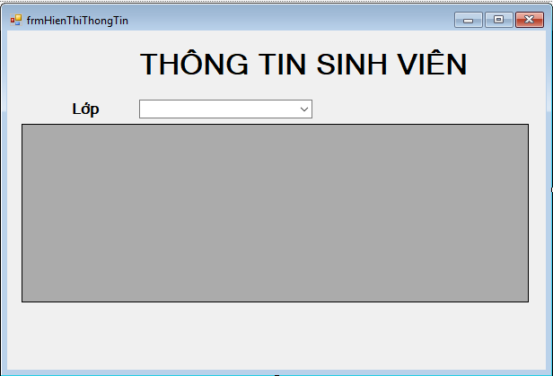

frmHienThiThongTin.cs

using System;

using System.Collections.Generic;

using System.ComponentModel;

using System.Data;

using System.Drawing;

using System.Linq;

using System.Text;

using System.Threading.Tasks;

using System.Windows.Forms;

using System.Data.SqlClient;

namespace FormDangNhap

{

public partial class frmHienThiThongTin : Form

{

SqlConnection conn = new SqlConnection(@"Data Source=THANHTUNG;Initial Catalog=Sign;Integrated Security=True");

SqlDataAdapter da;

public frmHienThiThongTin()

{

InitializeComponent();

}

private void frmHienThiThongTin_Load(object sender, EventArgs e)

{

da = new SqlDataAdapter("select * from lop", conn);

DataTable dt = new DataTable();

da.Fill(dt);

da.Dispose();

comboBox1.DataSource = dt;

comboBox1.DisplayMember = "tenlop";

comboBox1.ValueMember = "malop";

}

private void comboBox1_SelectedIndexChanged(object sender, EventArgs e)

{

da = new SqlDataAdapter("select * from sinhvien where malop = '" + comboBox1.SelectedValue + "'", conn);

DataTable dt = new DataTable();

da.Fill(dt);

da.Dispose();

dataGridView1.DataSource = dt;

}

}

}

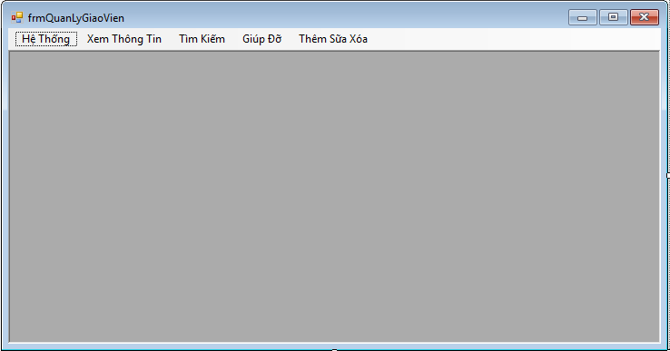

frmQuanlygiaovien

using System;

using System.Collections.Generic;

using System.ComponentModel;

using System.Data;

using System.Drawing;

using System.Linq;

using System.Text;

using System.Threading.Tasks;

using System.Windows.Forms;

namespace FormDangNhap

{

public partial class frmQuanLyGiaoVien : Form

{

public frmQuanLyGiaoVien()

{

InitializeComponent();

}

private void giáoViênToolStripMenuItem_Click(object sender, EventArgs e)

{

//this.Hide();

Form main = new frmThongTinGiaoVien();

main.Show();

}

private void giảiPhươngTrìnhToolStripMenuItem_Click(object sender, EventArgs e)

{

Form main = new frmGiaiPhuongTrinh();

main.Show();

}

private void sinhViênToolStripMenuItem_Click(object sender, EventArgs e)

{

Form main = new frmHienThiThongTin();

main.Show();

}

private void thêmSữaXóaToolStripMenuItem_Click(object sender, EventArgs e)

{

Form main = new frmTTSV();

main.Show();

}

}

}

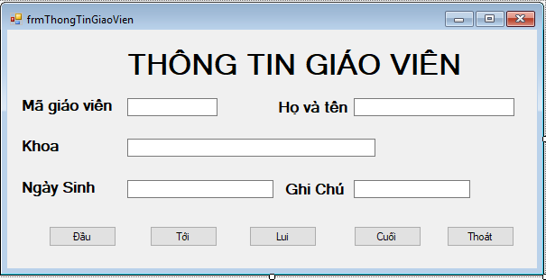

using System;

using System.Collections.Generic;

using System.ComponentModel;

using System.Data;

using System.Data.SqlClient;

using System.Drawing;

using System.Linq;

using System.Text;

using System.Threading.Tasks;

using System.Windows.Forms;

namespace FormDangNhap

{

public partial class frmThongTinGiaoVien : Form

{

SqlConnection conn;

SqlDataAdapter da;

//DataTable dt;

BindingSource source;

public frmThongTinGiaoVien()

{

InitializeComponent();

}

private void frmThongTinGiaoVien_Load(object sender, EventArgs e)

{

conn = new SqlConnection(@"Data Source=THANHTUNG;Initial Catalog=Sign;Integrated Security=True");

da = new SqlDataAdapter("select giaovien.magv, giaovien.tengv, giaovien.ngaysinh, giaovien.ghichu, lop.tenlop from giaovien, lop where giaovien.malop = lop.malop", conn);

DataTable dt = new DataTable();

da.Fill(dt);

source = new BindingSource();

foreach (DataRow dr in dt.Rows)

source.Add(dr);

ShowRecord();

}

private void ShowRecord()

{

DataRow currentRow = (DataRow)source.Current;

txtMaGiaoVien.Text = currentRow["magv"].ToString();

txtHoVaTen.Text = currentRow["tengv"].ToString();

txtKhoa.Text = currentRow["tenlop"].ToString();

txtNgaySinh.Text = currentRow["ngaysinh"].ToString();

txtGhiChu.Text = currentRow["ghichu"].ToString();

}

private void btnToi_Click(object sender, EventArgs e)

{

source.MoveNext();

ShowRecord();

}

private void btnDau_Click(object sender, EventArgs e)

{

source.MoveFirst();

ShowRecord();

}

private void btnLui_Click(object sender, EventArgs e)

{

source.MovePrevious();

ShowRecord();

}

private void btnCuoi_Click(object sender, EventArgs e)

{

source.MoveLast();

ShowRecord();

}

private void btnThoat_Click(object sender, EventArgs e)

{

this.Close();

}

}

}

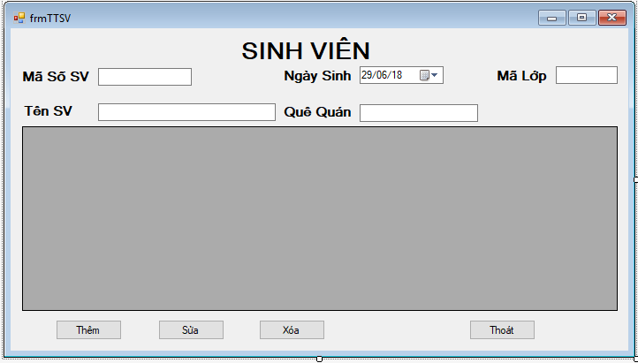

using System;

using System.Collections.Generic;

using System.ComponentModel;

using System.Data;

using System.Drawing;

using System.Linq;

using System.Text;

using System.Threading.Tasks;

using System.Windows.Forms;

using System.Data.SqlClient;

namespace FormDangNhap

{

public partial class frmTTSV : Form

{

public frmTTSV()

{

InitializeComponent();

}

private void frmTTSV_Load(object sender, EventArgs e)

{

load();

}

public void load()

{

ketnoi.openketnoi();

//load listBox

dataGridView1.DataSource = ketnoi.gettable("select * from sinhvien");

ketnoi.dongketnoi();

}

private void dataGridView1_CellContentClick(object sender, DataGridViewCellEventArgs e)

{

int t = dataGridView1.CurrentCell.RowIndex;

txtMSSV.Text = dataGridView1.Rows[t].Cells[0].Value.ToString();

txtHoVaTen.Text = dataGridView1.Rows[t].Cells[1].Value.ToString();

dateTimePicker1.Text = dataGridView1.Rows[t].Cells[2].Value.ToString();

txtQueQuan.Text = dataGridView1.Rows[t].Cells[3].Value.ToString();

txtMaLop.Text = dataGridView1.Rows[t].Cells[4].Value.ToString();

}

private void btnThem_Click(object sender, EventArgs e)

{

ketnoi.openketnoi();

ketnoi.executeQuery("insert into sinhvien values('" + txtMSSV.Text + "','" + txtHoVaTen.Text + "','" + dateTimePicker1.Text + "','" + txtQueQuan.Text + "','" + txtMaLop.Text + "')");

load();

}

private void btnSua_Click(object sender, EventArgs e)

{

ketnoi.openketnoi();

ketnoi.executeQuery("update sinhvien set mssv='" + txtMSSV.Text + "',tensv='" + txtHoVaTen.Text + "',ngaysinh='" + dateTimePicker1.Text + "',quequan='" + txtQueQuan.Text + "',malop='" + txtMaLop.Text + "' where mssv='" + dataGridView1.Rows[dataGridView1.CurrentCell.RowIndex].Cells[0].Value.ToString() + "'");

load();

}

private void btnXoa_Click(object sender, EventArgs e)

{

DialogResult = MessageBox.Show("Bạn có chắc muốn xóa!", "Thông báo", MessageBoxButtons.OKCancel, MessageBoxIcon.Warning);

if (DialogResult == DialogResult.OK)

{

ketnoi.openketnoi();

ketnoi.executeQuery("delete from sinhvien where mssv='" + dataGridView1.Rows[dataGridView1.CurrentCell.RowIndex].Cells[0].Value.ToString() + "' ");

load();

ketnoi.dongketnoi();

}

}

private void btnThoat_Click(object sender, EventArgs e)

{

this.Close();

}

}

}

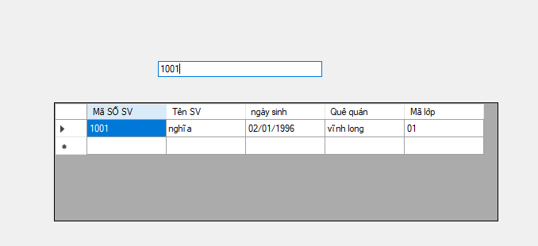

using System;

using System.Collections.Generic;

using System.ComponentModel;

using System.Data;

using System.Drawing;

using System.Linq;

using System.Text;

using System.Threading.Tasks;

using System.Windows.Forms;

using System.Data.SqlClient;

namespace FormDangNhap

{

public partial class Form1 : Form

{

public Form1()

{

InitializeComponent();

}

private void btntimkiem_Click(object sender, EventArgs e)

{

}

public DataTable hienthi(string sqlht)

{

ketnoi.openketnoi();

SqlDataAdapter mydata = new SqlDataAdapter(sqlht, ketnoi.con);

DataTable mydt = new DataTable();

mydata.Fill(mydt);

return mydt;

ketnoi.dongketnoi();

}

private void txttimkiem_TextChanged(object sender, EventArgs e)

{

dataGridView1.DataSource = hienthi("select mssv as 'Mã SỐ SV', tensv as 'Tên SV', ngaysinh as 'ngày sinh',quequan as 'Quê quán', malop as 'Mã lớp'from sinhvien where mssv like N'%" + txttimkiem.Text.Trim() + "%' ");

}

}

}

BÀI DANG NHẬP

Giao dien Form1.cs

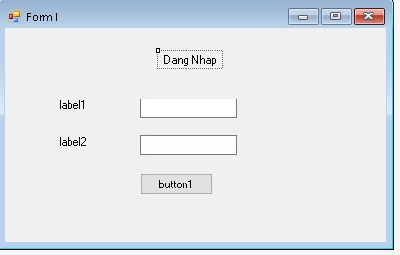

Class ketnoi.cs

using System;

using System.Collections.Generic;

using System.Linq;

using System.Text;

using System.Threading.Tasks;

using System.Data.SqlClient;

using System.Data;

namespace QLSV

{

class ketnoi

{

public SqlCommand cmd { get; set; }

public SqlConnection con;

public void OpenConnect()

{

con = new SqlConnection(@"Data Source=DESKTOP-NCK3RL1\SQLEXPRESS;Initial Catalog=QLDTKH;User ID=sa;password = system");

if (con.State == ConnectionState.Closed)

con.Open();

}

public DataTable bangdulieu = new DataTable();

public DataTable laybang(string caulenh)

{

try

{

OpenConnect();

SqlDataAdapter Adapter = new SqlDataAdapter(caulenh, con);

DataSet ds = new DataSet();

Adapter.Fill(bangdulieu);

}

catch (System.Exception)

{

bangdulieu = null;

}

finally

{

CloseConnect();

}

return bangdulieu;

}

public void CloseConnect()

{

if (con.State == ConnectionState.Open)

con.Close();

}

public int executeScala(string strSQL)

{

this.cmd = new SqlCommand(strSQL, this.con);

int temp = (int)cmd.ExecuteScalar();

return temp;

}

public bool executeUpdate(string strUpdate)

{

this.cmd = new SqlCommand(strUpdate, this.con);

int a = cmd.ExecuteNonQuery();

if (a >= 1)

return true;

return false;

}

}

}

Form1.cs

using System;

using System.Collections.Generic;

using System.ComponentModel;

using System.Data;

using System.Drawing;

using System.Linq;

using System.Text;

using System.Threading.Tasks;

using System.Windows.Forms;

using System.Data.SqlClient;

using System.Data;

namespace QLSV

{

public partial class Form1 : Form

{

public Form1()

{

InitializeComponent();

}

private void btndangnhap_Click(object sender, EventArgs e)

{

ketnoi cn = new ketnoi();

try

{

cn.OpenConnect();

string taikhoan = txttaikhoan.Text;

string matkhau = txtmatkhau.Text;

string sql = "select * from tblTaiKhoan where TaiKhoan = '" + txttaikhoan.Text + "' and MatKhau = '" + txtmatkhau.Text + "'";

MessageBox.Show("Đăng nhập thành công!");

this.Hide();

Form main = new Form2();

main.Show();

}

catch (Exception ex)

{

MessageBox.Show("" + ex);

}

}

}

}